SRI VENKATESA PERUMAL COLLEGE OF
ENGINEERING & TECHNOLOGY
(Affiliated to JNTU, Hyderabad)


MINI PROJECT ON
STUDENT STAFF FEEDBACK SYSTEM
DEPARTMENT OF
INFORMATION TECHNOLOGY
BY

P.JAYA PRAKASH 05G01A1205
Y.M KISHORE 05G01A1208
K.NARESH 05G01A1218

Under the valuable Guidance of

INTERNAL GUIDE HEAD OF THE DEPARTMENT
Sri P.KARTHIKEYAN, Sri E.MADHUSUDHANA REDDY,
Associate Professor, Dept. of Information Technology,
SVPCET, PUTTUR. SVPCET, PUTTUR.

SRI VENKATESA PERUMAL COLLEGE OF
ENGINEERING & TECHNOLOGY
(Affiliated to JNTU, Hyderabad)

MINI PROJECT ON
STUDENT STAFF FEEDBACK SYSTEM
DEPARTMENT OF
INFORMATION TECHNOLOGY
BY

P.JAYA PRAKASH 05G01A1205
Y.M KISHORE 05G01A1208
K.NARESH 05G01A1218

Under the valuable Guidance of

INTERNAL GUIDE HEAD OF THE DEPARTMENT
Sri P.KARTHIKEYAN, Sri E.MADHUSUDHANA REDDY,
Associate Professor, Dept. of Information Technology,
SVPCET, PUTTUR. SVPCET, PUTTUR.

ACKNOWLEDGEMENT

The satisfaction that accompanies the successful completion of any task would be incomplete without acknowledging those who have made it possible and to those who’s constant encouragement and guidelines has been a source of inspiration throughout the course if this project.

We are very much thankful to our Internal Guide Mr.P.Karthikeyan, Assistant Professor, for providing his valuable suggestions and guidance for the successful completion of this project.

We also thank Mr. E.Madhusudhana reddy Professor and the HOD of I.T for his valuable guidance, and his constant supervision without which carrying out this project would not have been possible.

We express our sincere gratitude to our principal Dr. C. Nadamuni Reddy, M.Tech, PhD. And our honorable chairman Mr. Ravuri Venkata Swamy for helping us in getting this project completed.

ABSTRACT

“Student Staff Feedback System” This system is generally used by four kinds of users:

- Student
- Staff
- Head of departments
- Principal

The application should have a database of questionnaire which will be given to the students after a secured login. A mechanism should be there to add, modify or delete a question to/from the database.

The application should evaluate the answers given by the students based on the feedback (which will be given by a no. 1 – 5) and a percentile / grade has to be generated to all the staff members of a particular department.

These feedback report was checked by the hods. He can view overall grades and view the grades obtained to the lecturers and give this report to the principal and he can give counseling to the college staff

We have developed Student Staff Feedback System to provide feedback in an easy and quick manner to the college principal and hods.So we call it as Student Staff Feedback System which delivers via the student staff interface as online system which acting as a Service Provider

By using this online system we make it better and quick way.

CONTENTS

- INTRODUCTION

- PROJECT ANALYSIS

2.1 KEY NOTES
2.2 HARDWARE REQUIREMENTS
2.3 SOFTWARE REQUIREMENTS
2. FEASIBILITY STUDY

- PROJECT DESIGN

3.1 UML DIAGRAMS
3.2 DATA TABLES

- CODING

- OUTPUT SCREENS

6. PROJECT TESTING

6.1 SOFTWARE TESTING
6.2 TESTING TECHNIQUES
6.3 TESTING STRATEGIES

7. CONCLUSION & ENHANCEMENTS

8. APPENDIX

9. BIBLOGRAPHY & ADDENDUM

1. INTRODUCTION

We have developed Student Staff Feedback System to provide feedback in an easy and quick manner to the college principal and Hod’s. So we call it as Student Staff Feedback System which delivers via the student staff interface as online system which acting as a Service Provider

By using this technology we can make fast feedback about the staff by students on time to head of departments as they referred in online system.

This project has four kinds of users Student, Staff, Hod’s, and Principal. The student can give feedback in online system provided by college staff. First of staff can prepare questions & add, update these questions to the online system. After that it was viewed by the students and can give feedback about the lecturers.

This feedback report was checked by the Hod’s. He can view grades and view the grades obtained to the lecturers and give this report to the principal and he give counseling to the college staff

Highlights:

- Cut your time – by giving feedback on online system when compared to the manual process this saves time of user.
- Manage the entire process – the entire process of giving feedback and viewing that report after giving feedback can manage easily
- Enhance the staff – find the details about the lecturer’s interest in teaching to the students
- Meet web standards – an easy to use system that successfully combines form with function

Using the latest Microsoft technology, the .Net framework and ASP.Net, our system is a complete feedback management and staff interaction system with built-in features proofing that easily supports Integration with the latest student staff feedback system providers

This system is designed to be simple to use, simple to understand and easy to implement and configure to fit. It is provided as an Application Service Provision thus offering low setup costs.

EXISTING SYSTEM:

Coming to the existing system the feedback is done by manual process. In the existing system students can give feedback about the lecturers by using paper and pen. By this process. Student can give feedback in online system without waste his time in writing. After giving feedback by every student. Papers are collected by the Hod’s and calculate the overall grade for each subject and each lecturer. After that those all grade report is viewed by the principal which is given by the Hod’s. Hence estimating the performance of lecturers and giving counseling to college staff.

So, the existing system is carries more time to do a piece of work for this reason
The online system feedback is implemented.

This is the major advantage of the existing system for giving feedback about the
Lecturers and viewing report of lecturers.

PROPOSED SYSTEM:

Here we aimed to design online web application for issuing the feedback about the lecturers by students, this is named as student staff feedback system. Student Staff feed
Back System to provide feedback in a easy and quick manner to the college principal and Hod’s. So we call it as Student Staff Feedback System which delivers via the student staff interface as online system which acting as a Service Provider

By using this technology we can make fast feedback about the staff by students on time to head of departments as they referred in online system.

This project has four kinds of users Student, Staff, Hod’s, and Principal. The student can give feedback in online system provided by college staff. First of staff can prepare questions and add, update these questions to the online system. After that it was viewed by the students and can give feedback about the lecturers.

These feedback reports were checked by the Hod’s. He can view overall grades and view the grades obtained to the lecturers and give this report to the principal and he can give counseling to the college staff

As compared to the manual system, online system is very simple to use and also understand.

Highlights:

- Saves your time
- Manage the entire process in easy and quick way
- Enhance the staff
- Improve the issuing standards

In the proposed system generally used by four kinds of users:

- Student
- Staff
- Head of departments
- Principal

By using this online system we make it better and quick way.

The proposed system consists of four modules:

- Student :
Student can give the feedback about the lecturers on the scale of five. Students can give feed back about the lecturer based on interaction of lecturer in the class room with students. According to that, students can give feedback as per the given grades.

- Staff:
The feedback given by the students can be viewed by the staff and improve their performance in teaching and other aspects

- Head Of Departments :

These feedback reports were checked by the Hod’s. He can view overall grades and view the grades obtained to the lecturers and give this report to the principal and he can give counseling to the college staff

  - Principal :

Finally, report was referred by the principal and give suggestions to lecturers to improve their teaching

These are the four modules present in the project so we have developed these things in very easy and clearly understandable way. So, by seen above description the proposed system having many advantages as compared to the existing system.

2.PROJECT ANALYASIS

STUDY OF THE SYSTEM:

MODULE DESCRIPTION
The project is mainly divided into three modules. They are

- Student module
- Staff module
- Head of the departments module
- Principal module

DESCRIPTION:

STUDENT MODULE:

The student will have the authorities on this as following:
- Add questions
- Update questions
- View questions
- Giving feedback about the lecturers

Add questions:

In this module the student or staff or Hod’s can add questions if he is interested to add another question to database to rate the lecturers.

Update questions:

In this module the student or staff or Hod’s can update
Questions.

View questions:

In this module students can view all questions in the database to give feedback about the lecturers

Giving feedback about the lecturers:

In this student can give feedback about the lecturer according to questions given in the database

STAFF MODULE:

The staff will have the authorities on this as following:
1) Add questions
- Update questions
- View questions
- View report

Add questions:

In this module the student or staff or Hod’s can add questions if he is interested to add another question to database to rate the lecturers.

Update questions:

In this module the student or staff or Hod’s can update questions.

View questions:

In this module students can view all questions in the database to give feedback about the lecturers

View report:

After giving feedback by the students; lecturers, Hod’s, principal can view report

HOD MODULE:

Hod’s will have the authorities on this as following:
1) Add questions
2) Update questions
- View questions
- View report

Add questions:

In this module the student or staff or Hod’s can add questions if he is interested to add another question to database to rate the lecturers.

Update questions:

In this module the student or staff or Hod’s can update questions.

View questions:

In this module students can view all questions in the database to give feedback about the lecturers

View report:

After giving feedback by the students; lecturers, Hod’s, principal can view report

PRINCIPAL MODULE:

Principal will have the authorities on this as following:
1) Add questions
- Update questions
- View questions
- View report
Add questions:

In this module the student or staff or Hod’s can add questions if he is interested to add another question to database to rate the lecturers.

Update questions:

In this module the student or staff or Hod’s can update questions.

View questions:

In this module students can view all questions in the database to give feedback about the lecturers

View report:

After giving feedback by the students; lecturers, Hod’s, principal can view report

This feedback report was checked by the Hod’s. He can view overall grades and view the grades obtained to the lecturers and give this report to the principal and he can give counseling to the college staff. Finally principal and Hod’s can organize the meeting and give instructions to the staff to improve the performance, communication to teach in a easier way.

KEY NOTES

INTRODUCTION TO .NET
.NET is a “software Platform”. It is a language-neutral environment for developing rich .NET experiences and building applications that can easily and securely operate within it. When developed applications are deployed, those applications will target. NET and will execute wherever .NET is implemented instead of targeting a particular Hardware/OS combination. The components that make up the .NET platform are collectively called the .NET Framework.
The .NET Framework is a managed, type-safe environment for developing and executing applications. The .NET Framework manages all aspects of program execution, like. Allocation of memory for the storage of data and instructions, granting and denying permissions to the application, managing execution of the application and reallocation of memory for resources that are not needed.
The .NET Framework is designed for cross-language compatibility. Cross-language compatibility means, an application written in Visual Basic .NET may reference a DLL file written in C# (C-Sharp). A Visual Basic .NET class might be derived from a C# class or vice versa.
Common Language Specification
The common Language Specification (CLS) describes a set of features that different languages have in common. The CLS includes a subset of Common Type System (CTS) which define the rules concerning data types and ensures that code is executed in a safe environment.

.NET FRAMEWORK ADVANTAGES
Some reasons why develops are building applications using the .NET Framework:
- Improved Reliability
- Increased Performance
- Developer Productivity
- Powerful Security
- Integration with existing Systems
- Ease of Deployment
- Mobility Support
- XML Web service Support
- Support for over 20 Programming Languages
- Flexible Data Access
- The .NET Framework offers a number a advantages to developers. The following paragraphs describe them in detail.
Improved Coding
The code can be done faster and more effectively. A multitude of enhancements to the code editor, including enhanced Intelligence, smart listing of code for greater readability and a background compiler for real-time notification of syntax errors transforms into a rapid application development (RAD) coding machine.
Direct Access to the Platform
Visual Basic developers can have full access to the capabilities available in .NET Framework 1.1. Developers can easily program system services including the event log, performance counters and file system.
The new Windows Service project template enables to build real Microsoft Windows NT services.

Full Object-Oriented Constructs
.Net allows creation of reusable, enterprise-class code using full object-oriented constructs. Language features include full implementation inheritance, encapsulation, and polymorphism. Structured exception handling provides a global error handler and eliminates spaghetti code.
XML Web Services `
XML Web services enable to call components running on any platform using open Internet protocols. Working with XML Web services is easier where enhancements simplify the discovery and consumption of

SYSTEM REQUIREMENTS:

- Hardware Requirements

- Processor: Pentium IV.
  - Speed: 3.06 GHZ.
  - Primary Memory: 256 MB RAM.
  - Hard Disk: 2GB.
The above specified requirements are the minimum required to run the application

- Software Requirements

- Language used: Visual Studio 2005, oracle 10-g.
- Platform : windows NT/ME/2000/XP
- Tools used: Internet explorer, Mozilla, Firefox.

FEASIBILITY STUDY:

  - Feasibility Assessment :

Feasibility study is a test of system proposal according to the workability, impact on the organization, ability to meet user needs and effective use of the available resources. The objective of feasibility study is not to solve the problem but to acquire a sense of its scope.
Three key combinations are involved in the feasibility analysis. They are:

- ECONOMICS FEASIBILITY:
Economic analysis is the most frequently used method for evaluating the effectiveness of a client system. More commonly known as cost/benefit analysis, the procedure is to determine the benefits and savings that are expecting from a client system and compare them with cost.
- TECHNICAL FEASIBILITY:
Technical feasibility centers on the existing system and to what extent it can support the proposed system. The benefits such as high accuracy, minimum response time and user friendliness of the proposed system over weights cost for designing and implementing the new system
- SCHEDULE FEASIBILITY:
The time schedule required for the development of the project is important, since more development time affects machine time and cost of delay in the development of other systems

3.PROJECT DESIGN

Software design is an interactive process through which requirements are translated into a ‘Blue Print’ for constructing the software. The design is represented at high level of abstraction, a level that can be directly translated to specific data, functional and behavioral requirements.
Preliminary design is concerned with the transformation of requirements into data and software architecture. Detailed design focuses on refinements to the architectural representation that lead to detailed data structure and algorithmic representation for software.

1Introduction to UML
The Unified modeling language (UML) provides a blueprint to Software Engineers and Developers. It is a Language for Specifying, Documenting, Visualizing and constructing the various aspects of a Software System.
UML is an Industry-Standard Modeling Language. It Contains a number of graphical notations and symbols (diagrams) that allow the analyst and designer of a Software Application to describe the architecture of the application in a graphical form.
Definition:
UML is a general purpose visual modeling language that is used to
- Specify
- Visualize
- Construct
- Document
The artifacts of the software system
2. Rules of the UML
The UML has semantic rules for
- NAMES : It will call things, relationships and diagrams
- SCOPE : The content that gives specific meaning to a name
- VISIBILITY : How those names can be seen and used by others
- INTEGRITY : How things properly and consistently relate to
Another
- EXECUTION : What it means is to run or simulate a dynamic model
3. Building blocks of UML
The vocabulary of the UML encompasses 3 kinds’ building blocks
- Things
- Relationships &Diagrams
3.1 Things: Things are the data abstractions that are first class citizens in a model. Things are of 4 types
a. Structural things
b. Behavioral things
c. Grouping things
d. An notational things
3.2 Relationships: Relationships tie the things together. Relationships in the UML are
a. Dependency
b. Association
c. Generalization & Specialization
3.3 Diagrams: Diagrams in the UML are of 2 types
- Static diagrams
- Dynamic diagrams
Static diagrams are
- Class diagram
- Object diagram
- Component diagram
- Deployment diagram

Dynamic diagrams are
- Use case diagram
- Sequence diagram
- Collaboration diagram
- State chat diagram
- Activity diagram

3.1 UML Diagrams
A diagram is a graphical representation of a set of elements. The various diagrams in UML are as follows:
4.1 CLASS DIAGRAM:
A Class diagram shows a set of classes, interfaces, and collaborations and their relationships. Class diagrams address the static design view of a system. Class diagrams that include Active classes address the static process view of a system.
A Class is a description of a set of objects that share the same attributes, operations, relationships, and semantics. A Class implements on or more interfaces.
4.2 OBJECT DIAGRAM:
An Object diagram shows the relationship between a group of objects and their relationships. Object diagrams represent static snapshots of instances of the things found in class diagrams. Object diagram address the static design view or static process view of a system.
4.3 USECASE DIAGRAM:
A Use case diagram shows a set of use cases and actors(a special kind of class) and their relationships. Usecase diagrams address the static use case view of a system. These diagrams are especially important in organizing and modeling the behaviors of a system.
4.4 SEQUENCE DIAGRAM:
A Sequence diagram is a visual representation of a scenario. A sequence diagram shows the various actors in the scenario, and the way they interact with all the subsystems.
A Sequence diagram is an interaction diagram that emphasizes the time ordering of messages.
4.5 COLLABORATION DIAGRAM:
A Collaboration diagram is an interaction diagram that emphasizes the structural organization of the objects that send and receive messages. Collaboration diagram address the dynamic view of a system.
4.6 STATECHART DIAGRAM:
A State chart diagram shows how an object dynamically changes its lifetime. A State is a condition or situation in which the object satisfies some condition, does some task, or waits for an event to trigger. A State chart diagram address the dynamic view of the system.

4.7 ACTIVITY DIAGRAM:
An Activity diagram is a special type of state chart diagram. It usually depicts the flow of events within an object. An Activity diagram addresses the dynamic view of a system. They are especially important in modeling the function of a system and emphasize the flow of control among objects.
4.8 COMPONENT DIAGRAM:
A Component diagram shows the organizations and dependencies among a set of components. Component diagram address the static implementation view of a system. They are related to class diagrams in that a component typically maps to one or more classes, interfaces, or collaborations.
4.9 DEPLOYMENT DIAGRAM:
A Deployment diagram shows the architecture of the execution time details of a system. Deployment diagram address the static deployment view of an architecture.
They are related to component diagrams in that a node typically encloses one or more components.
The following shows usecase diagrams, sequence diagrams for describing the system

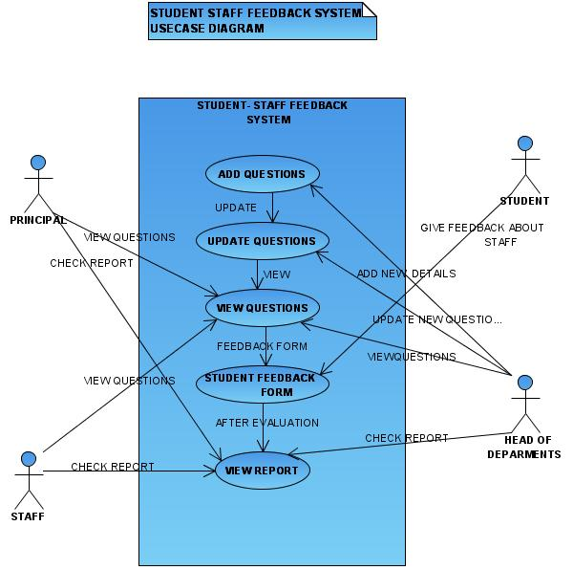

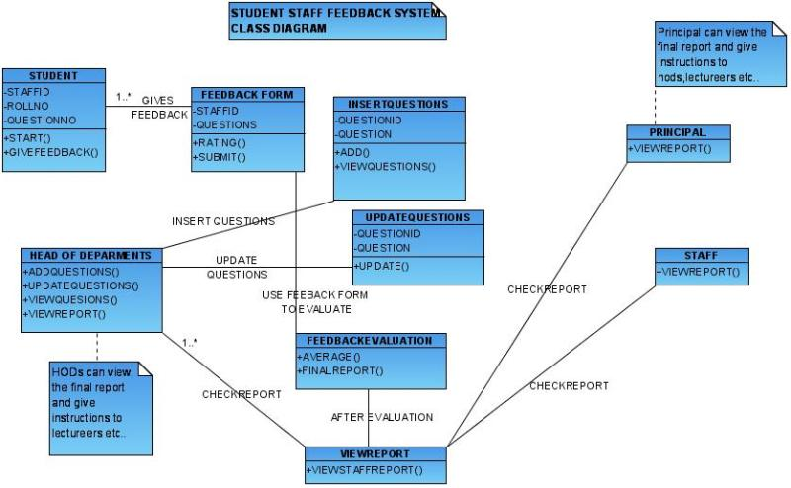

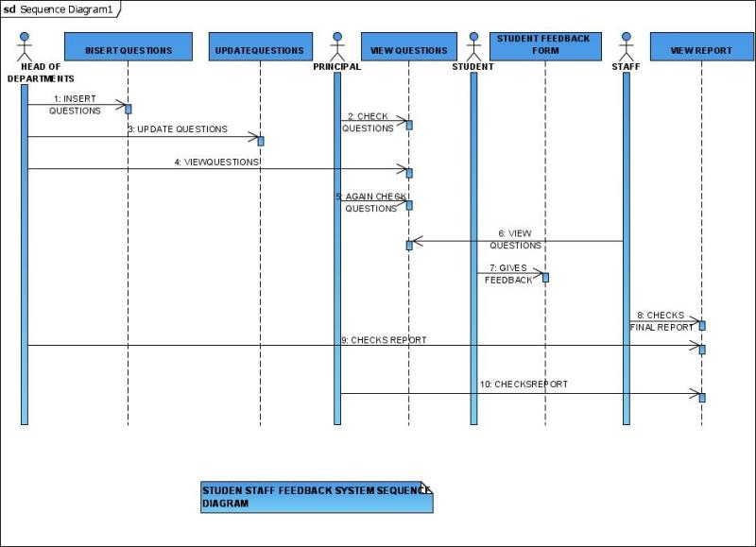

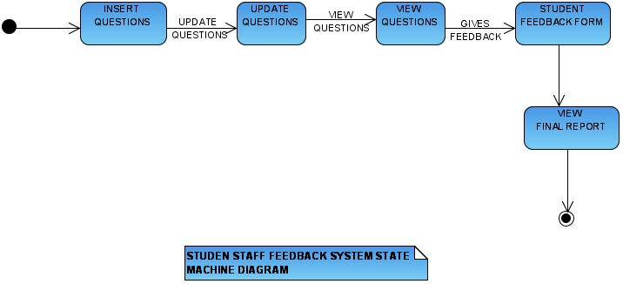

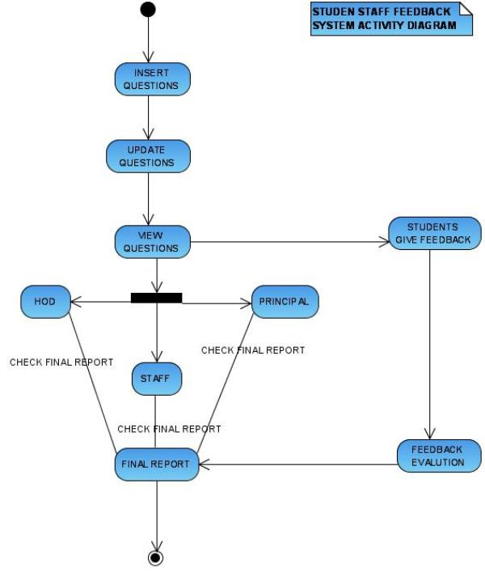

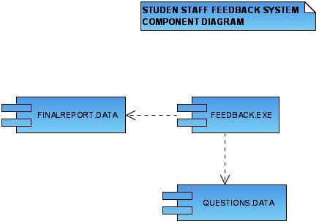

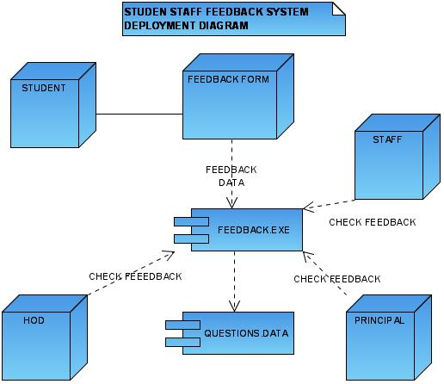

3.2 DATA TABLES:
A Database Management System is a set of pre-written programs that are used to store, update and retrieve the database.
The Various Data Tables used in this project are:-
VER | TABLE NAME | COLUMN DESCRIPTION
1.0 | QUESTIONINSERTION,  VIEWQUESTIONLIST,  UPDATEFORM | QUESTIONID NUMBER(10),  QUESTION VARCHAR(10)

TABLE 1

VER | TABLE NAME | COLUMN DESCRIPTION
1.0 | STUDENTFEEDBACKFORM | STAFFID VARCHAR(10),  ROLLNO VARCHAR(10),  QUESTIONNO NUMBER(10)

TABLE 2

4.CODING
.NET is a “software Platform”. It is a language-neutral environment for developing rich .NET experiences and building applications that can easily and securely operate within it. When developed applications are deployed, those applications will target. NET and will execute wherever .NET is implemented instead of targeting a particular Hardware/OS combination. The components that make up the .NET platform are collectively called the .NET Framework.
The following code is used to design student staff feedback system
HOME PAGE
Using System;
Using System. Data;
using System.Configuration;
using System.Collections;
using System.Web;
using System.Web.Security;
using System.Web.UI;
using System.Web.UI.WebControls;
using System.Web.UI.WebControls.WebParts;
using System.Web.UI.HtmlControls;

public partial class INDEX : System.Web.UI.Page
{
protected void Page_Load(object sender, EventArgs e)
{
}
protected void LinkButton1_Click(object sender, EventArgs e)
{
Server.Transfer("questioninsertion.aspx");
}
protected void LinkButton1_Click1(object sender, EventArgs e)
{
Server.Transfer("questioninsertion.aspx");
}
protected void LinkButton2_Click(object sender, EventArgs e)
{
Server.Transfer("updateform.aspx");
}
protected void LinkButton3_Click(object sender, EventArgs e)
{
Server.Transfer("viewquestionslist.aspx");
}
protected void LinkButton4_Click(object sender, EventArgs e)
{
Server.Transfer("studentfeedbackform.aspx");
}
protected void LinkButton5_Click(object sender, EventArgs e)
{
Server.Transfer("feedbackevaluation.aspx");
}
}
Save this as “INDEX.aspx.cs”

INSERTING QUESTIONS
using System;
using System.Data;
using System.Configuration;
using System.Web;
using System.Web.Security;
using System.Web.UI;
using System.Web.UI.WebControls;
using System.Web.UI.WebControls.WebParts;
using System.Web.UI.HtmlControls;
using System.Data.OleDb;

public partial class _Default : System.Web.UI.Page
{
protected void Page_Load(object sender, EventArgs e)
{

}
protected void TextBox1_TextChanged(object sender, EventArgs e)
{

}
protected void addbutton_Click(object sender, EventArgs e)
{
if (questiontextbox.Text.Equals(""))
requiredfield.Text = " Required field is Empty";
else
{
try
{
OleDbConnection conn;
OleDbCommand dc;
int questionid = int.Parse(questionidtextbox.Text);
string question = questiontextbox.Text;

conn = new OleDbConnection("Provider=MSDAORA.1;user id=svpcet;password=svpcet;data source=projects");
conn.Open();
dc = new OleDbCommand("insert into questiondatabase values(" + questionid + ",'" + question + "')", conn);
dc.ExecuteReader();
conn.Close();
resultlabel.Text = questionid + "user created successfully...";
}
catch (Exception exec)
{
resultlabel.Text = exec.Message;
}
}
}
protected void questionidtextbox_Init(object sender, EventArgs e)
{
OleDbConnection conn;
OleDbCommand dc;
OleDbDataReader dr;
string connectionstring = (string)ConfigurationSettings.AppSettings["ConnectionString"];
conn = new OleDbConnection(connectionstring);
conn.Open();
dc = new OleDbCommand("select max(questionid) from questiondatabase ", conn);
dr = dc.ExecuteReader();
dr.Read();
int incrno = int.Parse (dr.GetValue(0).ToString());
incrno ++;
questionidtextbox.Text =incrno .ToString ();
dr.Close();
conn.Close();
}
protected void listofquestionsbutton_Click(object sender, EventArgs e)
{
Server.Transfer("viewquestionslist.aspx");
}
protected void Button1_Click(object sender, EventArgs e)
{
Server.Transfer("INDEX.aspx");
}
}
Save this file as “questioninsertion.aspx.cs”

VIEW QUESTIONS
using System;
using System.Data;
using System.Configuration;
using System.Collections;
using System.Web;
using System.Web.Security;
using System.Web.UI;
using System.Web.UI.WebControls;
using System.Web.UI.WebControls.WebParts;
using System.Web.UI.HtmlControls;
using System.Data.OleDb;

public partial class viewquestionslist : System.Web.UI.Page
{
protected void Page_Load(object sender, EventArgs e)
{
OleDbConnection conn;
OleDbCommand dc;
OleDbDataAdapter da;
string connectionstring = (string)ConfigurationSettings.AppSettings["ConnectionString"];
conn = new OleDbConnection(connectionstring);
conn.Open();

dc = new OleDbCommand("SELECT QUESTIONID, QUESTION FROM QUESTIONDATABASE", conn);

dc.CommandType = CommandType.Text;
da = new OleDbDataAdapter(dc);
DataSet ds = new DataSet();
da.Fill(ds);
dc.ExecuteReader();
DataGrid1.DataSource = ds;
DataGrid1.DataBind();

conn.Close();
}
protected void backbutton_Click(object sender, EventArgs e)
{
Server.Transfer("questioninsertion.aspx");
}
protected void Button1_Click(object sender, EventArgs e)
{
Server.Transfer("INDEX.aspx");
}
}
Save this file as “viewquestionlist.aspx.cs”

UPDATE QUESTIONS
using System;
using System.Data;
using System.Configuration;
using System.Collections;
using System.Web;
using System.Web.Security;
using System.Web.UI;
using System.Web.UI.WebControls;
using System.Web.UI.WebControls.WebParts;
using System.Web.UI.HtmlControls;
using System.Data.OleDb;

public partial class updateform : System.Web.UI.Page
{
protected void Page_Load(object sender, EventArgs e)
{

}
protected void questionidList_Init(object sender, EventArgs e)
{
questionidlist.Items.Clear();

OleDbConnection conn;
OleDbCommand dc;
OleDbDataReader dr;
string connectionstring=(string)ConfigurationSettings.AppSettings["ConnectionString"];
conn = new OleDbConnection(connectionstring);
conn.Open();
dc = new OleDbCommand("select questionid from questiondatabase", conn);
dr = dc.ExecuteReader();
while (dr.Read())
{
string username = dr.GetValue(0).ToString();
questionidlist.Items.Add(username);

}
dr.Close();
conn.Close();
}
protected void updatebutton_Click(object sender, EventArgs e)
{
int questionid;
if (questiontextbox.Text.Equals(""))
requiredfield.Text = " Required field is Empty";
else
{
try
{
OleDbConnection conn;
OleDbCommand dc;
questionid = int.Parse(questionidlist.Text);
string question = questiontextbox.Text;
string connectionstring = (string)ConfigurationSettings.AppSettings["ConnectionString"];
conn = new OleDbConnection(connectionstring);

conn.Open();
dc = new OleDbCommand("update questiondatabase set question='" + question + "' where questionid=" + questionid + " ", conn);
dc.ExecuteReader();
conn.Close();
resultlabel.Text = questionid + " updated successfully...";
}
catch (Exception exec)
{
resultlabel.Text = exec.Message;
}
}
}
protected void Button1_Click(object sender, EventArgs e)
{
Server.Transfer("INDEX.aspx");
}
}
Save this file as “updateform.aspx.cs”

STUDENT FEEDBACK FORM
using System;
using System.Data;
using System.Configuration;
using System.Collections;
using System.Web;
using System.Web.Security;
using System.Web.UI;
using System.Web.UI.WebControls;
using System.Web.UI.WebControls.WebParts;
using System.Web.UI.HtmlControls;
using System.Data.OleDb;

public partial class studentfeedbackform : System.Web.UI.Page
{
string staffid;
string rollno;
static int questionno;

protected void Page_Load(object sender, EventArgs e)
{
finishbutton.Visible = false;
}
protected void questionidtextbox_Init(object sender, EventArgs e)
{

}
protected void startbutton_Click(object sender, EventArgs e)
{
staffid = staffidtextbox.Text;
rollno = rollnotextbox.Text;
suggestionlabel.Visible = true;

if(staffid.Equals (""))
{
requiredfieldlabel .Text = " please fill this field " ;
}
else if (rollno.Equals(""))
{
requiredfieldlabel1.Text = " please fill this field ";
}
else
{
staffidtextbox.ReadOnly = true;
rollnotextbox.ReadOnly = true;
startbutton.Visible = false;
nextbutton.Visible = false ;
submitbutton.Visible = true;
questionidtextbox.Text = "1";
scalinglist.Visible = true;
OleDbConnection conn;
OleDbCommand dc;
OleDbDataReader dr;
string connectionstring = (string)ConfigurationSettings.AppSettings["ConnectionString"];
conn = new OleDbConnection(connectionstring);
conn.Open();
dc = new OleDbCommand("select question from questiondatabase where questionid='" + questionidtextbox.Text + "'", conn);
dr = dc.ExecuteReader();
dr.Read();
questiontextbox.Text = dr.GetValue(0).ToString();

dr.Close();
conn.Close();

}

}

protected void submitbutton_Click(object sender, EventArgs e)
{
submitbutton.Visible = false;

nextbutton.Visible = true;
OleDbConnection conn1;
OleDbCommand dc1;
OleDbDataReader dr1;

string connectionstring1 = (string)ConfigurationSettings.AppSettings["ConnectionString"];
conn1 = new OleDbConnection(connectionstring1);
conn1.Open();
dc1 = new OleDbCommand("select max(questionid) from questiondatabase", conn1);
dr1 = dc1.ExecuteReader();
dr1.Read();
int max = int.Parse(dr1.GetValue(0).ToString());

if (questionno.Equals(max))
{
nextbutton.Visible = false;
finishbutton.Visible = true;

}
dr1.Close();
conn1.Close();
OleDbConnection conn;
OleDbCommand dc;
string staffid = staffidtextbox.Text;
string rollno = rollnotextbox.Text;
int questionid=int.Parse (questionidtextbox .Text);
int scaling=int.Parse (scalinglist .Text );
String connectionstring = (string)ConfigurationSettings.AppSettings["ConnectionString"];
conn = new OleDbConnection(connectionstring);
conn.Open();
dc = new OleDbCommand("insert into studentsfeedback values('" + staffid + "','" + rollno + "'," + questionid +"," + scaling +" )", conn);
dc.ExecuteReader();
conn.Close();

}
protected void nextbutton_Click(object sender, EventArgs e)
{
submitbutton.Visible = true;
nextbutton.Visible = false;
OleDbConnection conn;
OleDbCommand dc;
OleDbDataReader dr;
questionno = int.Parse(questionidtextbox.Text);
questionno++;
string connectionstring = (string)ConfigurationSettings.AppSettings["ConnectionString"];
conn = new OleDbConnection(connectionstring);
conn.Open();
dc = new OleDbCommand("select question from questiondatabase where questionid=" + questionno + "", conn);
dr = dc.ExecuteReader();
dr.Read();

questionidtextbox.Text = questionno.ToString () ;
questiontextbox.Text = dr.GetValue(0).ToString();
dr.Close();
conn.Close();

OleDbConnection conn1;
OleDbCommand dc1;
OleDbDataReader dr1;

string connectionstring1 = (string)ConfigurationSettings.AppSettings["ConnectionString"];
conn1 = new OleDbConnection(connectionstring1);
conn1.Open();
dc1 = new OleDbCommand("select max(questionid) from questiondatabase", conn1);
dr1 = dc1.ExecuteReader();
dr1.Read();
int max = int.Parse (dr1.GetValue(0).ToString()) ;

if (questionno.Equals(max))
{
nextbutton.Visible = false;
submitbutton.Visible = true ;
finishbutton.Visible = true;

}
dr.Close();
conn.Close();
}
protected void finishbutton_Click(object sender, EventArgs e)
{
Server.Transfer("INDEX.aspx");
}
}
Save this as “studentfeedbackform.aspx.cs”

FEEDBACK EVALUATION
using System;
using System.Data;
using System.Configuration;
using System.Collections;
using System.Web;
using System.Web.Security;
using System.Web.UI;
using System.Web.UI.WebControls;
using System.Web.UI.WebControls.WebParts;
using System.Web.UI.HtmlControls;
using System.Data.OleDb;

public partial class feedbackevaluation : System.Web.UI.Page
{
protected void Page_Load(object sender, EventArgs e)
{
OleDbConnection conn;
OleDbCommand dc;
OleDbDataAdapter da;
string connectionstring = (string)ConfigurationSettings.AppSettings["ConnectionString"];
conn = new OleDbConnection(connectionstring);
conn.Open();

dc = new OleDbCommand("SELECT STAFFID, AVG(FEEDBACKQUESTIONVALUE) AS EXPR1 FROM STUDENTSFEEDBACK GROUP BY STAFFID", conn);

dc.CommandType = CommandType.Text;
da = new OleDbDataAdapter(dc);
DataSet ds = new DataSet();
da.Fill(ds);
dc.ExecuteReader();
DataGrid1.DataSource = ds;
DataGrid1.DataBind();

conn.Close();
}
protected void Button1_Click(object sender, EventArgs e)
{
Server.Transfer("INDEX.aspx");
}
}
Save this as “feedbackevaluation.aspx.cs”

5.OUTPUT SCREENS

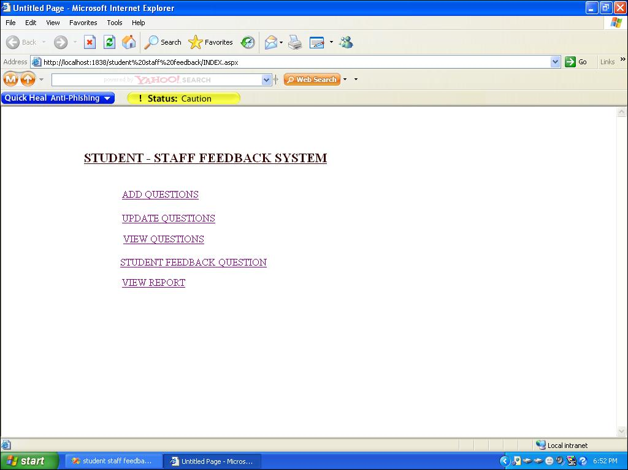

fig: The above output screen shows the student staff feedback system home page

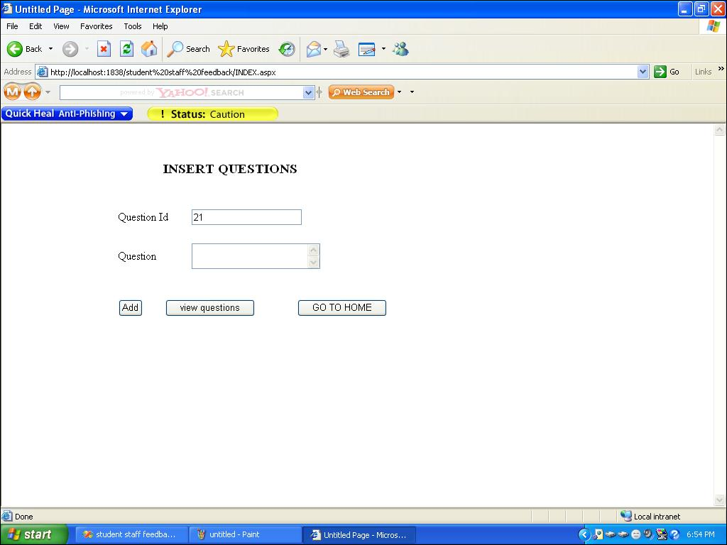

fig: The above output screen shows the student staff feedback system for inserting questions

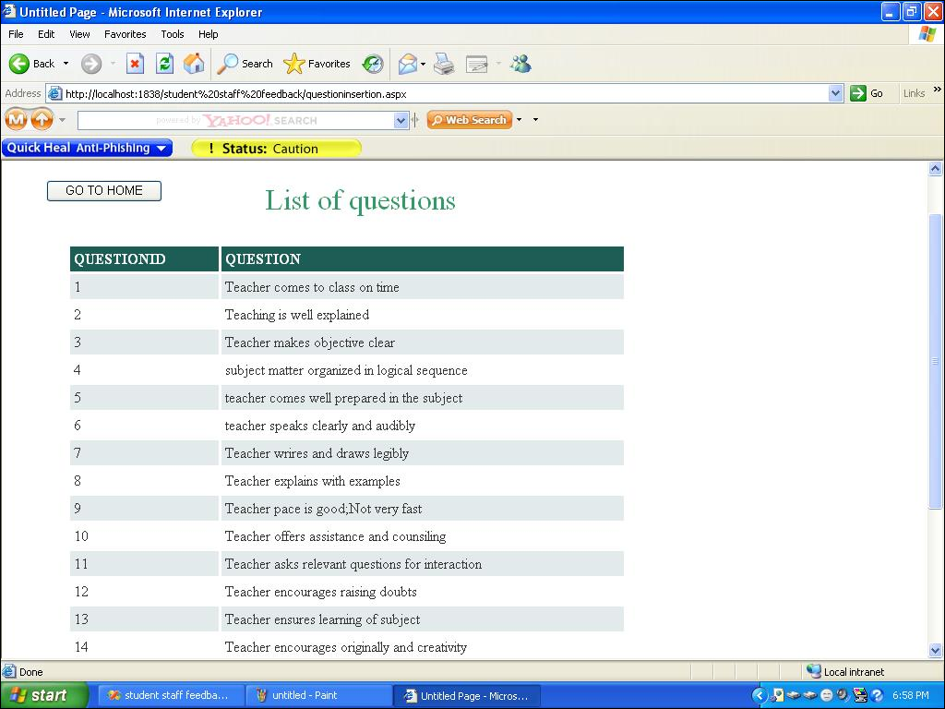

fig: The above output screen shows the student staff feedback system for viewing
list of questions

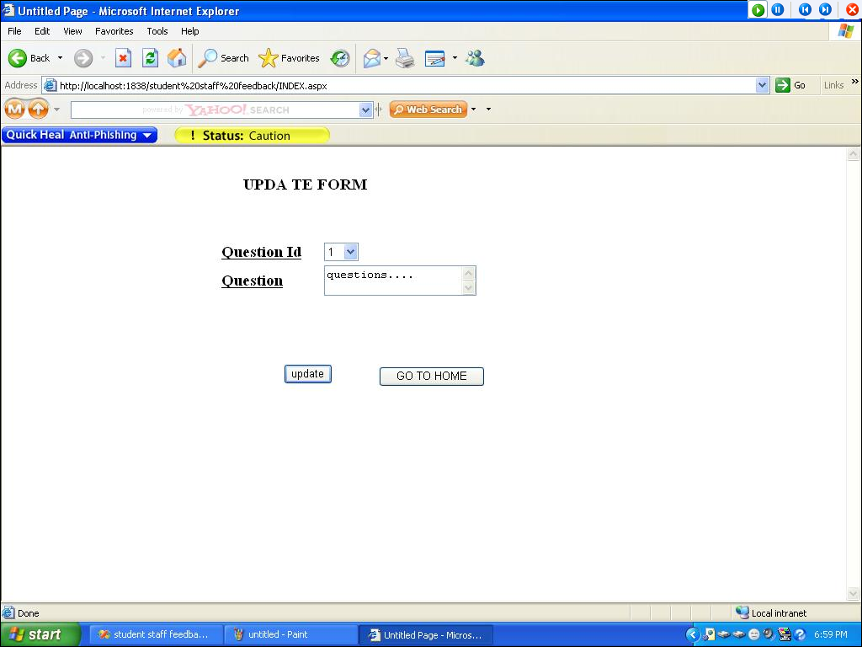

fig: The above output screen shows the student staff feedback system for updating questions

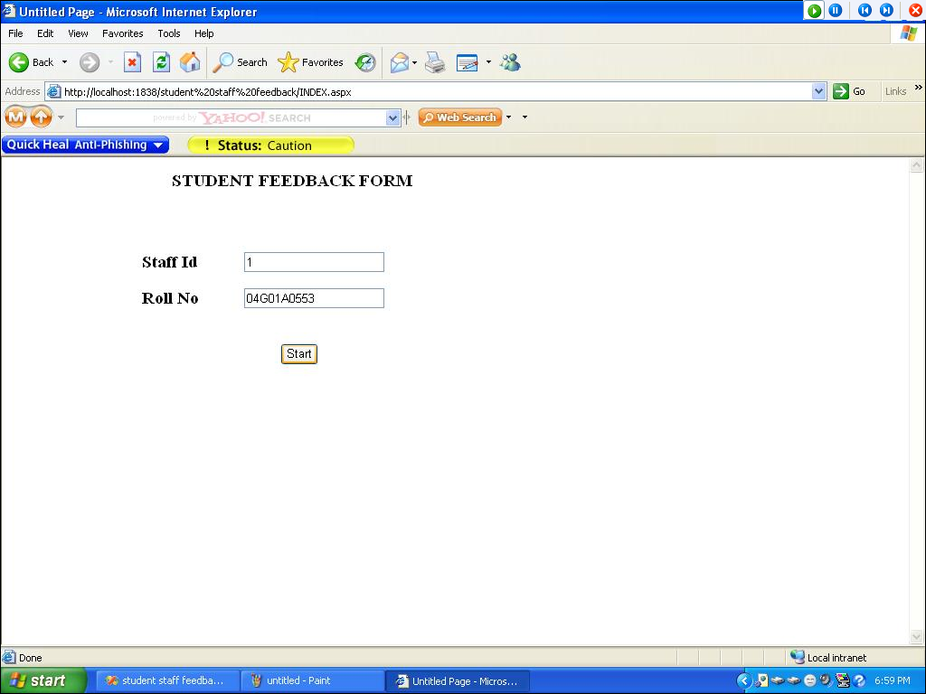

fig: The above output screen shows the student staff feedback system for starting feedback system by students

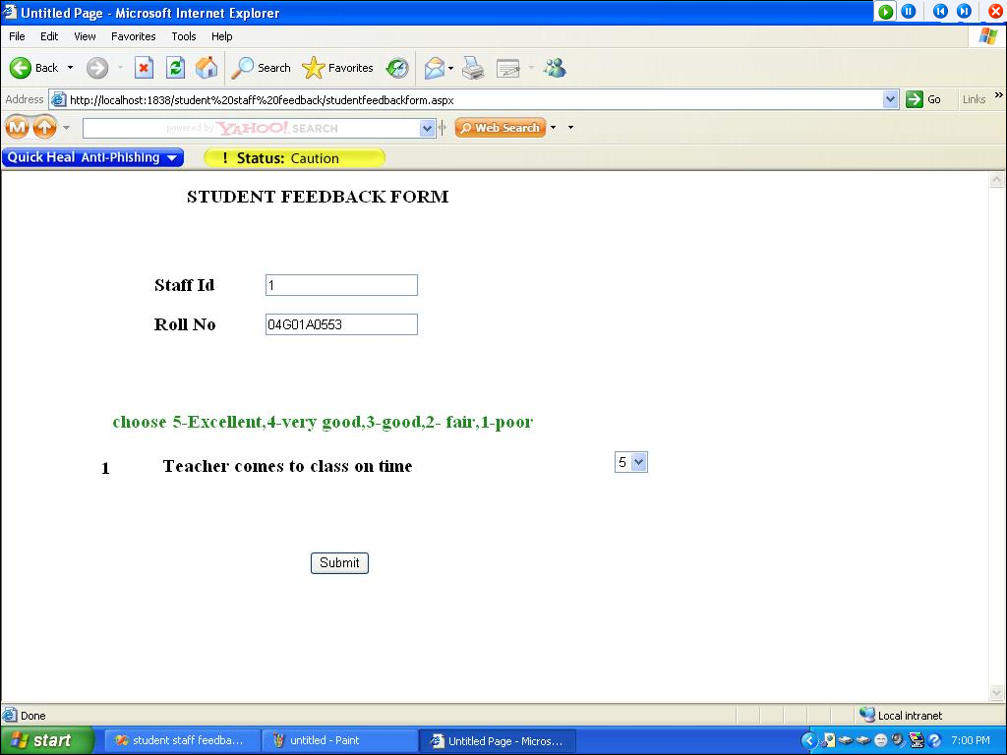

fig: The above output screen shows the student staff feedback system for starting feedback system by students

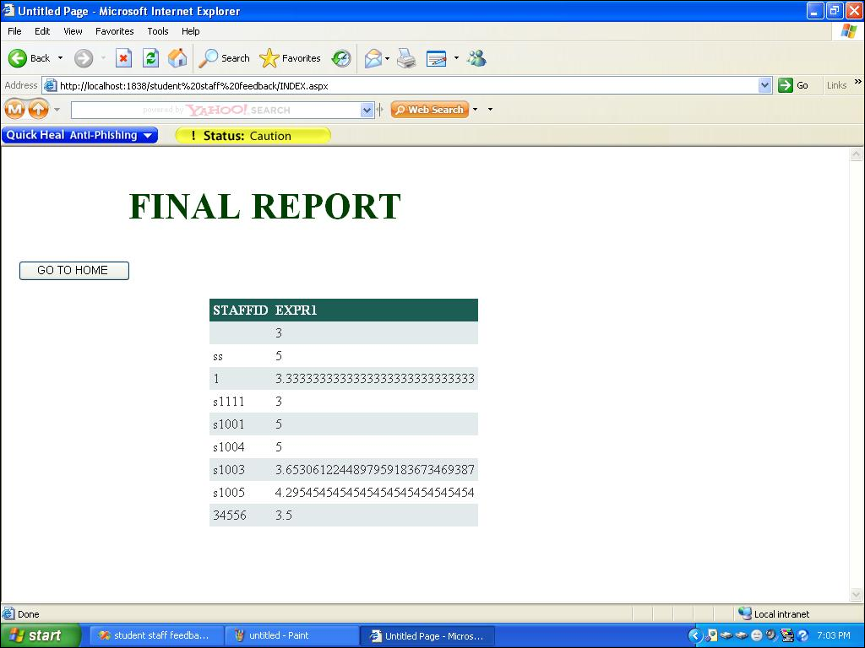

fig: The above output screen shows the student staff feedback system for viewing final report about lecturers

6.PROJECT TESTING
1. Software Testing
Software testing is a critical element of software quality assurance and represents the ultimate reuse of specification. Design and code testing represents interesting anomaly for the software during earlier definition and development phase, it was attempted to build software from an abstract concept to tangible implementation.
The testing phase involves, testing of the development of the system using various techniques such as White Box Testing, Control Structure Testing.

2. Testing Techniques

2.1 White Box Testing
White box testing is a test case design method that uses the control structure of the procedural design to derive test cases. After performing white box testing it was identified that
- The Leave Recording System (LRS) software guarantees that all independent paths within the modules have been exercised at least once.
- It has been exercised all logical decisions on their true and false sides.
- It was tested to execute all loops at their boundaries and within their Operational bounds
- It was tested for the internal data structures to ensure their validity.
2.2 Control Structure Testing
The following tests were conducted and it was noted that the BCBS is performing them well.
- Basic path Testing
- Condition Testing
- Data Flow Testing
- Loop Testing
Black box testing methods focuses on the functional requirements of the software by conducting black box testing using the methods Equivalence Partitioning Boundary Value Analysis and Cause-Effect-Graphing techniques.
- Functional validity of LRS checked.
- Checked the isolation of the boundaries of a class.
The tolerance of the system for the data rates and data volumes

3. Testing Strategies
A strategy for software testing must accommodate low-level tests that are necessary to verify that a small source code segment has been correctly implemented as well as high level against customer requirements.

3.1 Unit Testing:
Unit testing focuses verification on the smaller unit of software design such as form. This is known as form testing. The testing is done individually on each form. Using the unit test plan, prepared in design phase of the system development as a guide, important control paths are tested to uncover within the boundary of the module. In this step, the module is working satisfactorily as a regard to the expected output from the module

3.2 Integration Testing:
Data can be lost across an interface, one module can have an adverse effect on another sub function, when combined, may not produce the desired major function. Integration testing is a systematic technique for constructing the program structure while at the same time conducting tests to uncover errors associated with the interface. All the modules are combined in the testing step. Then the entire program is as a whole.
Different integrated test plans like top down integration and bottom up integration are tested and different errors found in the system are corrected using them. Finally, all the combined modules are performed well.
3.3 System Testing:
Testing the entire system as a whole and checking for its correctness is system testing. The system is listed for dispensaries between the system and its original objectives. This project was effective and efficient.

7. CONCLUSION AND ENHANCEMENTS

Conclusion:

The Project “Student Staff FeedBack system” is designed in order reduce the burden of maintaining bulk of records of all the students feedback details of who study in an Educational Institution. Inserting, retrieving and updating the feedback details of a student are easy when it is compared to the manual feedback and storing. Maintaining the project is also easy which can is easily understandable. Maintaining the details in the database is manageable.

Future Enhancements:

Due to the lack of time, the design part is not done so attractive. Further enhancements can be made in designing the screens. Some more forms can also be added so as to better retrieve the feedback details. Various other options can also be added for the better usability of project.

8.APPENDIX
The .NET Framework is designed for cross-language compatibility. Cross-language compatibility means, an application written in Visual Basic .NET may reference a DLL file written in C# (C-Sharp). A Visual Basic .NET class might be derived from a C# class or vice versa.
COMPONENTS OF .NET FRAMEWORK:
- Common Language Runtime (CLR)
- Class Libraries

Windows Forms
Controls
Drawing
Windows Application Services
Active Server Pages
Web Services
Web Forms
ASP .NET Application Services

ADO.NET
XML
Threading
.NET Framework Base Classes
IO
Security
Diagnostics
Net
Etc

Memory Management
Common Type System
Common Language Runtime

Figure: DOT NET Architecture

Common Language Specification:
The common Language Specification (CLS) describes a set of features that different languages have in common. The CLS includes a subset of Common Type System (CTS) which define the rules concerning data types and ensures that code is executed in a safe environment

ACRONYMS
UML UNIFIED MODELING LANGUAGE
SQL STRUCTURED QUERY LANQUAGE
DBMS DATA BASE MANAGEMENT SYSTEM

9.BIBLIOGRAPHY
ADDENDUM:
http://www.w3schools.com/aspnet/default.asp
http://www.w3schools.com/ado/default.asp
www.amazon.com/ASP-Programmers-Reference-Jason-Bell
www.amazon.com/Programming-Microsoft-ASP-NET-Core
http://www.w3schools.com/aspnet/aspnet_dbconnection.asp

TEXT BOOKS:
- Software Engineering by Roger S. Pressman (Tata Mc-Graw hill,5th edition)
- Data Base Management System by RaghuRamaKrishnan (Tata Mc-Graw hill,3rd edition)
- Unified Modeling Language 2 tool kit by Nons-Erik Eriksson, Magnus penkee, Brian lyons,Davidfode (2nd Edition)
- NET (Core Reference) -by Jeff Prosise
- ASP NET in a Nutshell - by G Andrew Duthie
- ASP Net by Example - by Steven A. Smith
- ASP.NET with C#, Wrogs United Limited

- The Unified Modeling Language User Guide by Grady Booch (Pearson education)

